What is Static Testing?
Static Testing, a software testing technique in which the software is tested without executing the code. It has two parts as listed below:
- Review - Typically used to find and eliminate errors or ambiguities in documents such as requirements, design, test cases, etc.
- Static analysis - The code written by developers are analysed (usually by tools) for structural defects that may lead to defects.
- Types of Reviews:
The types of reviews can be given by a simple diagram:
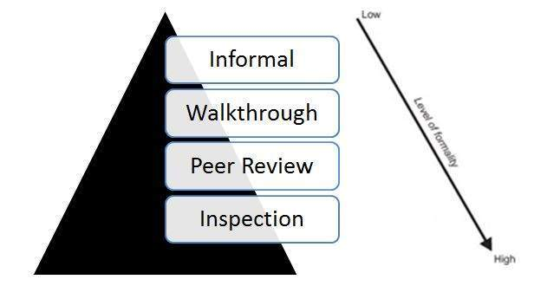

What is Informal Review?

Informal reviews are applied many times during the early stages of the life cycle of the document. A two person team can conduct an informal review. In later stages these reviews often involve more people and a meeting. The goal is to keep the author and to improve the quality of the document. The most important thing to keep in mind about the informal reviews is that they are not documented.

What is Walkthrough?

Method of conducting informal group/individual review is called walk through, in which a designer or programmer leads members of the development team,testing team and other interested parties through a software product, and the participants ask questions and make comments about possible errors, violation of development standards, and other problems or may suggest improvement on the article, walk through can be pre-planned or can be conducted at need basis and generally people working on the work product are involved in the walk through process.

The Purpose of walk through is to:

Find problems

Discuss alternative solutions

Focusing on demonstrating how work product meets all requirements.

What is Peer Review?
A peer review, a review technique, which is a static white-box testing which are conducted to spot the defects early in the life cycle that cannot be detected by black box testing techniques.

Peer Review Characteristics:
- Peer Reviews are documented and uses a defect detection process that has peers and technical specialist as part of the review process.
- The Review process doesn't involve management participation.
- It is usually led by trained moderator who is NOT the author.
- The report is prepared with the list of issues that needs to be addressed.

What is an Inspection?
Inspection is the most formal form of reviews, a strategy adopted during static testing phase.

Characteristics of Inspection :
- Inspection is usually led by a trained moderator, who is not the author. Moderator's role is to do a peer examination of a document
- Inspection is most formal and driven by checklists and rules.
- This review process makes use of entry and exit criteria.
- It is essential to have a pre-meeting preparation.
- Inspection report is prepared and shared with the author for appropriate actions.
- Post Inspection, a formal follow-up process is used to ensure a timely and a prompt corrective action.
- Aim of Inspection is NOT only to identify defects but also to bring in for process improvement.
- Static Analysis - By Tools:
Following are the types of defects found by the tools during static analysis:
- A variable with an undefined value
- Inconsistent interface between modules and components
- Variables that are declared but never used
- Unreachable code (or) Dead Code
- Programming standards violations
- Security vulnerabilities
- Syntax violations
Advantages of Static Reviews:-
1. Types of defects that can be found during static testing are: deviations from standards, missing requirements, design defects, non-maintainable code and inconsistent interface specifications.
2. Since static testing can start early in the life cycle, early feedback on quality issues can be established, e.g. an early validation of user requirements and not just late in the life cycle during
acceptance testing.
3. By detecting defects at an early stage, rework costs are relatively low and thus a relatively cheap improvement of the quality of software products can be achieved.
4. The feedback and suggestions document from the static testing process allows for process improvement, which supports the avoidance of similar errors being made in the future.
Roles and Responsibilities in a Review
There are various roles and responsibilities defined for a review process. Within a review team, four types of participants can be distinguished: moderator, author, scribe ,reviewer and
manager.Lets discuss their roles one by one:-
1. The moderator:- The moderator (or review leader) leads the review process. His role is to determine the type of review, approach and the composition of the review team.The moderator also
schedules the meeting, disseminates documents before the meeting, coaches other team members, paces the meeting, leads possible discussions and stores the data that is collected.
2. The author:- As the writer of the ‘document under review’, the author’s basic goal should be to learn as much as possible with regard to improving the quality of the document.The author’s
task is to illuminate unclear areas and to understand the defects found.
3. The scribe/ recorder :– The scribe (or recorder) has to record each defect found and any suggestions or feedback given in the meeting for process improvement.
4. The reviewer:- The role of the reviewers is to check defects and further improvements in accordance to the business specifications, standards and domain knowledge.

